Semiconductor Packaging Course Module 4

# Lesson 1

# Testing at different stages

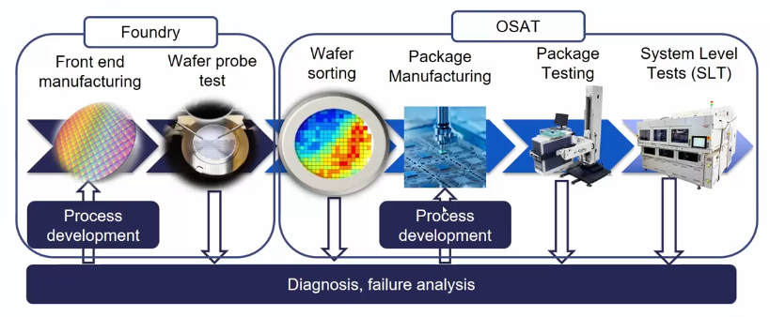The first place where we see or do testing is either at the foundry or the OSAT at the die level. This test is called the wafer probe test. We also have big machines which test the package along with the SLTs which test different systems at the OSAT.

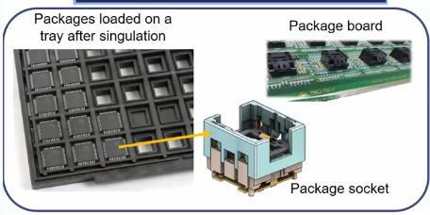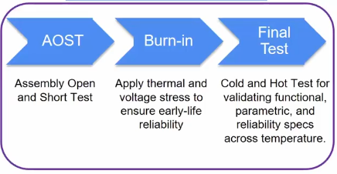Now let’s dive into package testing.

First, the individual packages are loaded onto a tray and then put on a package board which is then passed through the following three tests.

1. AOST – Assembly Open and Short Test

This is essentially a functionality test.

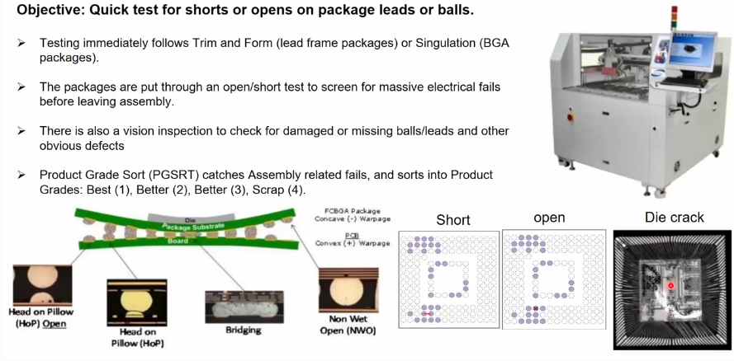

1. Burn-in Test

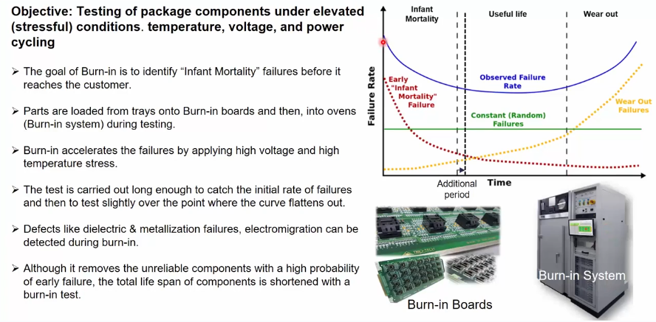We apply stress to the product early to find out if it is durable and reliable enough or not.

1. Final Test

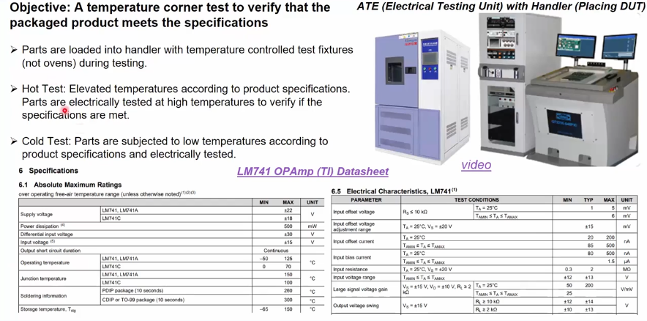Here the package is tested according to the guidelines provided in the datasheet to double check its functionality.

